SHRI RAMDEOBABA COLLEGE OF ENGINEERING AND MANAGEMENT, NAGPUR

DEPARTMENT OF COMPUTER SCIENCE & ENGINEERING

PRACTICAL LIST

SUBJECT: OBJECT ORIENTED PROGRAMMING (CSP206)

SEMESTER:IV(SHIFT –I , SHIFT – II)

SESSION: 2015-16

1. Write a program to demonstrate method overloading.

Create a class Shape and overload a method named perimeter() to calculate perimeter of different geometric shapes like square, circle, rectangle, triangle. Create main() to implement all the methods.

1. Write a program for passing object as parameter.

Create a class Fraction which stores numerator and denominator part of a fraction. Add functions in class Fraction to Compare, Add , Subtract and Display fractions. Write a main() method for implementing it.

1. Write a program to implement Inheritance and method overriding.

Create a class College with data members as College name, Location and PrincipalName and a function display() to display college information.. Derive a Class Department having data members DeptName and HODName and a function display() to display department information. Derive a class Person from Department having name and DOB, with methods calcAge() and display().

Derive two classes Student and Staff from Person. Student has data member as marks and calcGrade() to calculate grade. Staff has data member salary and computeTax(). Write a main() to test all the classes by creating instances of them.

1. Write a program to implement multiple inheritance.

Consider a class Employee with data members as employee id and employee name. Create an interface taxable which has method calculateTax(). Derive a class permanent from class employee and interface taxable. Data member for permanent is Salary, include function AdditionalEarning which stores information if there is additional earning. Calculate tax for the permanent employee. If salary for an employee is between 1 lakh to 5 lakh tax is 10%. If salary is more than 5 lakh tax is 20%. Add a function to display the salary and tax. Derive a class HourlyEmployee from Employee. Data members are HoursWorked, RatePerHour. Include methods to calculate salary and display it. Write proper constructors and display methods for all the classes. Write a main() to demonstrate use of all the classes.

1. Write a program to use static keyword.

Create a class User having non static data member username, password, logintime, static data member count, to count the number of users created for class User. In this class create a static method int loggedinseconds(), static void DisplayCount() to display count , non static void Display() to display username, logintime, counter and non static void loggedinseconds() to calculate since how long user is logged in. Write a program to create objects of class User and use various methods. Also demonstrate the use of static members using class name.

1. Demonstrate the concept of abstract class and dynamic method dispatch.

Write a program to create a graphic class hierarchy. Create an abstract class Figure with abstract display() , abstract length(). Derive two classes open and close from it. Class close contain abstract method area(). Derive 2 more classes’ polygon and eclipse from close. Derive line from class open. Create class point with data members as x and y, a constructor and display(). Line uses the class point’s object to define the start and end point of line. In all the classes include overridden method to display data members. Demonstrate dynamic method dispatch on display and length method. Include appropriate constructors in all classes.(Area of eclipse is $A=πab$ where a is major radius and b is minor radius, area of polygon is (s2n)/2tan(180/n) where s length of one side and n number of sides.)

1. Write a program to handle user defined exceptions.

In a department of a college, an employee ID is given as “CS007”. In a department there can be maximum 50 employees, with employee IDs ranging from “CS001” to “CS050”. There are three departments in college having codes “CS”, “IT” and “EC”. Create a class Employee having data members ID and Name. Write getdata method to get data. Perform user defined exception handling to handle above constraints.

1. Demonstrate use generic class and generic method.

A. Create a class Gen<T extendes Number> having data member T nums[]. Include method average() for calculating average of nums[], isAvgSame using wildcard to check if average of two gen objects is same.

Create another class Gen2. Include static method

<T, V extends T> boolean IsIn(T, V[])

To check whether V[] contains T.

1. Create a class Item having private data members item_name, rate, quantity. Include a constructor to initialize the values in item class. Include a display method to display the values in class, getRate() and getQunatity() which would return rate and quantity respectively. Create an arraylist “ArrItem” to store objects to class item.

Create an arraylist “ArrBill”. Calculate the total amount for each bill and display it. Use iterator to traverse the arraylist.

1. Write a program to use TreeSet collection with Comparator.
2. Demonstrate inter thread communication using Dining Philosopher Problem
3. Design User Interface for a mini calculator with standard arithmetic functions using Swing Components and appropriate event handling mechanism.

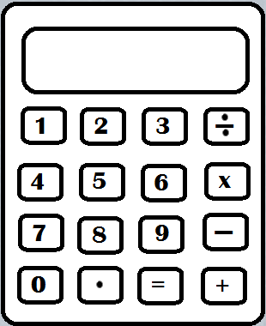

1. Design a UI for Registration Page as follows:

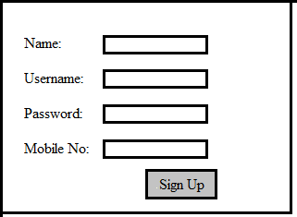

On click of Sign Up button, all data should be stored in a file.

1. Perform database connectivity.

Perform above practical using java database connectivity. On save button click the data should be saved in database.